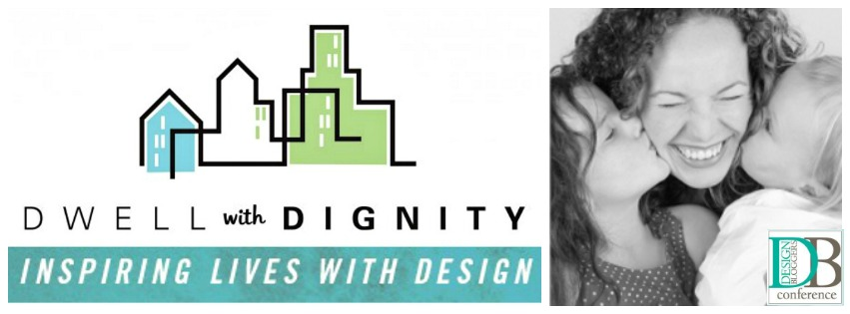
Coming up this Sunday, the charity organization, Dwell with Dignity, will be presenting at the Design Bloggers Conference in Atlanta. Dwell with Dignity is a Dallas-based non-profit organization dedicated to helping families escape poverty and homelessness through volunteer design time, monetary & house-hold donations, and their bi-annual Thrift Studio Event. One of the first public appearances of the Dwell with Dignity organization was on the Nate Berkus Show in the summer of 2011. Since then, this charitable organization has been creating inspiring homes with the labor of dedicated volunteers along with the generosity of dedicated donors, rapidly helping to change people’s lives, one household at a time. This short video can give you a peek into the good Dwell with Dignity does...

[INSERT VIDEO WITH THIS CODE:]
<iframe allowfullscreen="" frameborder="0" height="360" src="//www.youtube.com/embed/NJAnQ8sZhcM?rel=0" width="640"></iframe>

Dwell with Dignity's belief is: "If we can change a person’s surroundings, we can change their outlook on life. Exposing children (especially) to a nurturing home environment, that includes good design and art, can inspire a standard of living that will carry-over to future generations. Exposing parents to this same environment will allow them to see the positive impact it has on their family; inspiring them to maintain a standard of living they can be proud of and thrive in."

Lisa Robison - Founder & President of Dwell with Dignity

Kim Turner - VP & Director of Dwell with Dignity

Dwell with Dignity was founded by Dallas Interior Designers looking to give back to their community - Founder & President Lisa Robison and VP & Director Kim Turner. Lisa's strong belief that good design improves ones quality of life resulted in the incorporation of this non-profit foundation in April of 2009. Soon afterwards, Kim joined Lisa and is credited with building awareness of Dwell with Dignity throughout the design community - which has resulted in amazing support from luxury brands such as Neiman Marcus, Duxiana, and recently featured here on Hadley Court, Peacock Alley, to name a few.

Speaking of Peacock Alley support - Peacock Alley will be hosting a "Wrap Party" this Sunday in honor of Dwell with Dignity wrapping up their FIRST Atlanta home instillation and first installation outside of the Dallas Market! Bravo!! What a wonderful way to kick off the Design Bloggers Conference this year!



Congratulations Dwell with Dignity!
If you're in Atlanta, this is an event not to be missed - Celebrate the First DwD Project in Atlanta
and learn how to get involved with our next one!

A huge component of building awareness and fund raising for the Dwell with Dignity foundation has come from their bi-annual pop-up shop event they host called Thrift Studio - but don't let the term 'thrift' fool you. Each Thrift Studio event includes a cast of fabulous Dallas designers who design and install vignettes accumulated at the DWD warehouse, along with items the designers have donated from their own inventory. All items are on sale during the three-week event, allowing Dwell with Dignity to raise funds for items needed to help families escape poverty and homelessness with the design time they give back to the community.
Dwell with Dignity finds the families in need by working with existing social service organizations that have programs in place to help struggling families attain self-sufficiency. Agencies must have accountability- based programs that address housing, education, career, finance, life skills and children’s needs. Organizations that are approved by our board may nominate families in need.
The Dwell with Dignity Thrift Studio event celebrates both design and philanthropy. Through your support and generosity, they are able to make an impact on Dallas communities - and evolving to grow additional community chapters, their first outside of Dallas being Atlanta. This Spring's Thrift Studio design dream team features some of the best designers and tastemekers from Dallas, including:



Jan Showers
Sarah Pickard
Robert Allen Design
Julio Quinones
Culp Associates
Tompkins Lloyd Interiors
David Sutherland Showroom
SWOON, the Studio
Mecox



This Spring's Honorary Chair is Ronda Carman. Ronda is founder of the lifestyle blog, All The Best along with being the author of the Designers at Home: Personal Reflections on Stylish Living (Rizzoli 2013), contributing writer for Huffington Post, New York Social Diary, a reviewer for the prestigious Mr. & Mrs. Smith Hotel Collections, and a frequent speaker on the topic of design and social media. A Texan by birth, Ronda divides her time between the United Kingdom, the United States and the window seat of an airplane.
The Thrift Studio Event will be open to the public April11 - May 10, Tues - Sat, 10am - 5:30 pm, with a Preview Party event hosted on April 10 at 6pm. The Thrift Studio will be located at:

International on Turtle Creek Design Center
150 Turtle Creek Blvd. Suit 204
Dallas Texas


Dwell with Dignity is also partially underwritten by the Dallas Market Center - which is also sponsor of the Design Bloggers Conference this year.



Last October, Dwell with Dignity launched a new addition to their Thrift Studio concept: The Thrift Studio - Art Studio. A donation of an original piece of art will enable DWD to increase their fund raising ability to reach their mission, and for artists who donate, it will enable you to expose your work to the Dallas designers and tastemakers. All entries must be received by Friday, March 21 to be eligible for designer vignette consideration. For additional information and inquiries, please visit Art Auction - Thrift Studio.
Below is a peek at just two of the gorgeous vignettes designers were able to create for last Spring's Thrift Studio Event - all created from donated items, and sold to raise funds for Dwell with Dignity's charity.
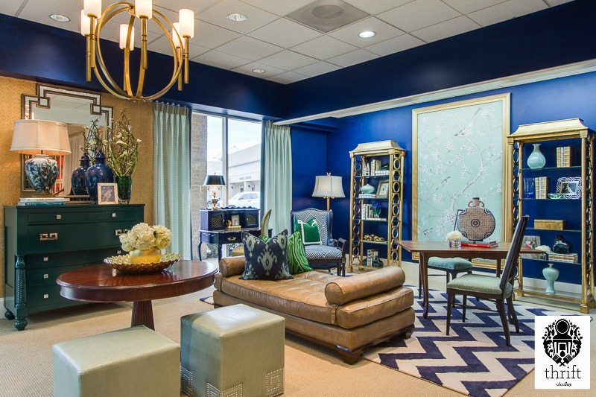
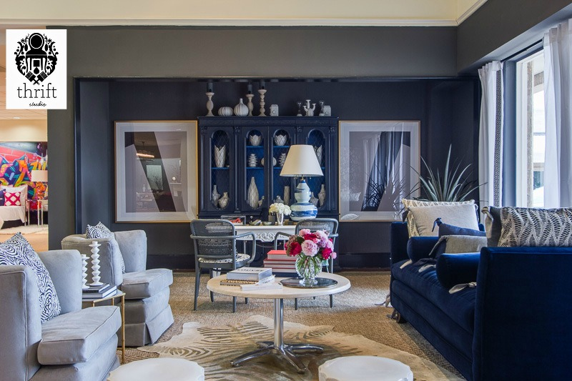

For more information about Dwell with Dignity, including becoming a volunteer plus donating new or gently used homegoods based on their required needs, please visit their website at DwellWithDignity.org, where you can also become a member of their community with your donation. You can also join them on their Facebook page, or even follow some of their project boards created by Kim Turner on Pinterest.

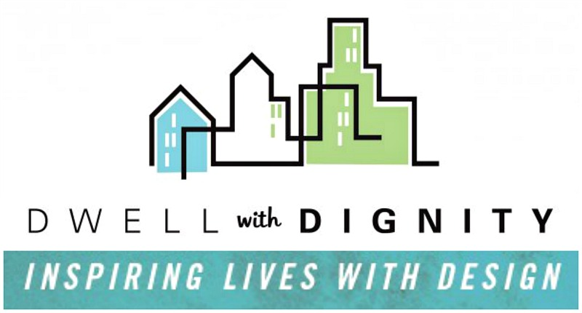

Personally, I'm a believer in Dwell with Dignity's cause. For the past three years, I've been watching them grow, helping spread their word through social media, and hoping for other chapters to open outside the Dallas area so I can volunteer. With Dwell now branching out to the Atlanta area, it looks like this just may be happening soon - And all the more why I was honored to guest blog about them today for you on Hadley Court.

Thank you,
Guest Contributor
Lynda Quintero-Davids

